Optum is introducing a new method of Multi Factor Authentication (MFA) for DWS Employee Portal login for enhanced

security. This will now require the use of the **Microsoft Authenticator** app to receive the six digit one-time passcode

every time you log in. Please follow these instructions on how to do this.

1. Search for and Download the Microsoft Authenticator App to your device (phone or tablet).

1. Go to the DWS Employee Portal page and login with your username (email address) password and click Log In:

1. 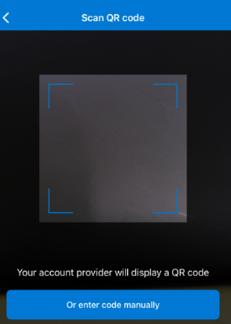A screenshot of a phone

   Description automatically generatedA screenshot of a qr code

   Description automatically generatedThe first time logging in, after you enter your username and password, a page with a QR Code will appear (sample below) – it will display a QR code for use with **Microsoft Authenticator only**. Open the Microsoft Authenticator App, press the plus sign, then Othe Account, then **Scan a QR code** button. (You will need to do this the first time only using MS Authenticator) This will open the QR code reader shown below:

Hover the QR code reader over the QR code displayed in the Employee Portal:

A six-digit code will appear on your device – go to step 4, below.

**Alternatively,**

Click the  button, if you prefer,

(You will only need to do this the first time using MS Authenticator)

Then type in the 32-digit text code shown like this sample (do not use):

A six-digit code will appear on your device,

1. Type the six-digit code in the Employee Portal, here: 

(Six-digit codes are valid for 30 seconds, then a new code is displayed. It’s fine to wait & use the next code)

1. Employee Portal will open:

1. All logins after the first one are faster. After entering your user name and password this screen will appear:

1. Open MS Authenticator, select the ‘Employee Portal App’ option, a six-digit code will appear.
2. Type in the six-digit code and you will be logged in as usual. Six-digit codes are valid for 30 seconds and then will refresh.
3. Any issues, email us at [int.eaponsite@optum.com](mailto:int.eaponsite@optum.com)